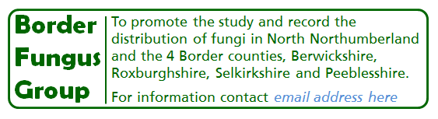

Dates for 2018
Borders Fungus Group - meetings are on Saturdays unless stated otherwise and start at 10.30am
BFG = Border Fungus Group
FGSES = Fungus Group of South East Scotland - meetings are on Sundays and start at 11am

April
8 FGSES foray Abbotsford estate (Ron)
21 BFG foray Gordon Moss

May
6 FGSES foray Portmore estate (Cameron)
19 BFG foray College Burn, Kirknewton

June
3 FGSES foray Eskbank (Chris)
23 BFG foray Threapwood Moss

July
1 FGSES foray Eildon hills (Ron)
21 BFG foray Bowmont Forest

August
5 FGSES foray Glentress (Greg)
11 BFG foray Marchmont
18 Provisional Roy’s 80th birthday foray - potentially Carrifran

September
2 FGSES & CAFG joint foray TBC
8 BFG foray Bamburgh

October
7 FGSES foray Loch of the Lowes (Nev)
12 / 13 / 14 Waxcap Weekend, The Sill, Haltwhistle Liz Holden & Cameron
Sunday 21 at 11.00am BFG & North East Fungus Study Group joint foray Kyloe Woods

November
4 FGSES & CAFG joint foray
17 BFG foray Harestanes

December
2 FGSES Bush Estate
15 BFG foray Spottiswoode

Ron McBeath 01289 308515 ron@lambertonnursery.co.uk

