Survey of selected waxcap grasslands on Hadrian's Wall in Northumberland National Park

Report to Northumberland National Park

January 2014

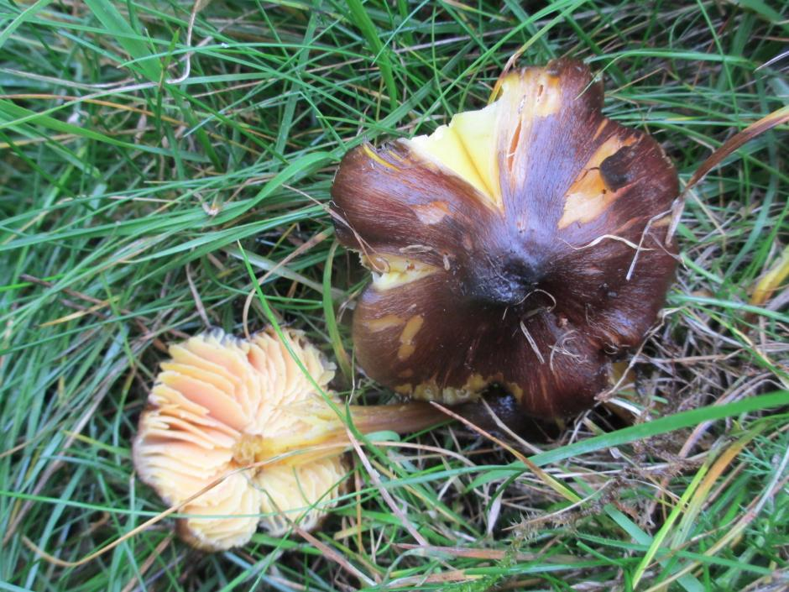
Hygrocybe spadicea (Date Waxcap): UK Biodiversity Action Plan species

Liz Holden Allanaquoich, Mar Lodge Estate, Braemar, Ballater, Aberdeenshire AB35 5YJ
Email: liz@marmycology.co.uk tel.: 013397 41410

CONTENTS
Main findings.............................................................................................. 3
Introduction................................................................................................. 3
Methodology............................................................................................... 4
Using criteria for assessment of the value of waxcap grasslands... 6

Results
UK Biodiversity Action Plan (UKBAP) species, Preliminary Assessment
red list species and other species of conservation interest............. 8
Interpreting the data......................................................................... 8
Sub site reports.................................................................................. 10
Discussion..................................................................................................... 15
Management recommendations…………………………………………......... 15
References…………………………………………………………………….. 16

Appendix 1: Waxcap grassland quality scoring system McHugh et al 2001... 18
Appendix 2: Full list of CHEGD species from Hadrian's Wall.......................... 19

Main findings
- UK Biodiversity Action Plan species (UKBAP): Three of the four unimproved grassland species with UKBAPs have now been recorded on Hadrian's Wall within the Northumberland National Park: Entoloma bloxamii (Big Blue Pinkgill), Hygrocybe spadicea (Date Waxcap) and Microglossum olivaceum (Olive Earthtngue).
- Preliminary assessment red list species: Hygrocybe spadicea and Clavaria straminea (Straw Club) were recorded in 2013
- National importance: when taken as one site united by the climatic, geological and management restrictions associated with the presence of a major archaeological feature in an upland setting, Hadrian's Wall grasslands sustain the highest number of Hygrocybe (waxcap) species in England and the third highest in the UK.
- International importance: the waxcap grasslands of northern Europe are rare elsewhere in the world. Areas of traditionally managed waxcap grassland in the UK are highly valued for their biodiversity in an international context. With its national importance, Hadrian's Wall will also be of international importance.
- Hadrian's Wall offers an excellent opportunity to set up an SSSI designated for its waxcap grassland interest.
- Agri-environment schemes should be investigated to support land users undertaking traditional, low input management methods.
- Sub sites of particular conservation interest: 'Steel Rigg car park: west of' is an outstanding area in its own right and would be worthy of consideration as an SSSI.
'Highshields Crags' supports a colony of Hygrocybe spadicea and as such also warrants particular attention paid to the maintenance of its grazing levels and low imput management practices.
- Entoloma species were assessed for the first time in 2013. Steel Rigg car park: west of and Limestone corner sites both supported good numbers of fruit bodies and diversity of species and these sites could be of particular interest for the genus.

Introduction
Fungi underpin the health of every habitat on the planet, including grasslands. The ability of these organisms to break down lignocellulose makes them a major driver of the carbon cycle although they are rarely taken into account in any kind of biodiversity or conservation assessments.

It is estimated that some 400 species of fungi in North-Western Europe are found in grasslands (Arnolds & de Vries 1989). A particular subset of grassland species has been associated with less disturbed, unfertilised, short sward grassland, the CHEGD fungi. CHEGD is an acronym of Clavariaceae (the 'fairy club' and 'coral' fungi), Hygrocybe (waxcaps), Entoloma (grassland species of this genus 'pink gills'), Geoglossaceae ('earthtongues') and Dermoloma (which also includes the genera Camarophyllopsis and Porpoloma). For ease of reference, habitats that support a high diversity of CHEGD species are known as 'waxcap grasslands'. This particular habitat, largely the result of traditional grazing management in the UK (although it can also be maintained by mowing), is thought to have declined by 90% since 1940 (Hewins et al 2005), mostly as a result of agricultural intensification.

The decline of the CHEGD fungi was first noted by Arnolds (1982, 1988) in the Netherlands and lead to a series of UK surveys (McHugh et al 2001; Newton et al 2003; Evans 2003; Griffith et al 2006). These studies established not only that the UK contains a relatively large number of sites with high diversity of CHEGD species but also the extent of under recording pre 1990 which means that declines can only be inferred from loss of habitat and apparent increases in the apparent distribution and abundance of these fungi can mask what is in reality a significant decline (Griffith et al 2013).

It should be noted that despite the continuity of low input management on good waxcap grassland sites, such sites are often poor in higher plant interest. This lack has been one of the main reasons that the conservation interest of such sites have been overlooked in the past. Öster (2008) found little congruence between higher plants and macrofungal diversity. Holden (2010) also found that higher plants cannot be relied upon to predict fungal diversity. The explanation may be that higher plant diversity is much reduced by heavy grazing pressure. Soil inhabiting fungi (eg CHEGD species) are less disturbed by grazing and will fruit in very short swards (Griffith et al 2013). It is interesting to speculate that the presence of CHEGD species in a plant poor site might indicate a site that would respond well to management to promote wild flowers. With careful management of hay cutting timing and grazing, the two should be able to co-exist.

It should also be noted that a high diversity of waxcap fungi has been suggested as an indication of the high diversity of other soil micro-organisms (Bardgett & McAlister 1999) an area of biodiversity that has been even more neglected than the fungi. The need for an undisturbed soil profile (in both mechanical and nutrient terms) appears to be common to both. Griffith et al (2013) indicate that it is important to highlight the difference between physical disturbance (e.g. localised quarrying) and chemical disturbance caused by the addition of synthetic fertilisers (a relatively recent phenomenon occurring over the last 50 years or so). The latter is potentially much more damaging.

The presence of evidence of past ground disturbance at several of the best sites (West of Steel Rigg car park, Limestone Corner, Walltown Crags: north), is entirely in keeping with the findings of Griffith et al (2013). Griffith suggests that there may be distinct successional processes which occur in soil following single episode physical disturbance and that it may be possible CHEGD fungi do well on 'recovering' sites.

The aim of this study is to assess the national and international conservation importance of the Hadrian's Wall (HW) grasslands for the CHEGD fungi.

Methodology
It is proposed that for the purposes of overall assessment (see Table 4) and this report, the length of Hadrian's Wall (HW) within the Northumberland National Park (NNP), be considered as one site: an area approx 25km by 100m i.e. 50m either side of HW and giving a total area of 250 hectares. It should be noted that this area is an estimate only, calculated on the basis that some areas along the wall will be of no fungal interest, whilst elsewhere the area of interest will extend away from the wall for several hundred metres. The particular circumstances of the area suggest that certain land management activities will not take place, giving it a cohesion as a site that many other collections of hotspots lack. The international importance of the site, reflected in its designation as a World Heritage Site, means that future management will have to take into account the need to preserve the archaeology. Thus building development or afforestation will not take place in the immediate vicinity of the monument.

Within Northumberland National Park, the upland nature of the site and the underlying geology whereby rock is often close to or protruding from the surface means that intensive agricultural practices involving ploughing or intensive fertilisation have historically rarely been appropriate. In these areas land use has been restricted to grazing for sheep, cattle or horses. Where such grazing has persisted on unimproved grassland, the soil profiles and low nutrient levels will have been in place for several hundreds of years. These areas are potentially outstanding for their waxcap grassland fungi and can form hot spots or refugia populations.

Building on existing survey work (Mclay 2012), a subset of 8 hotspot sites (Table 1) was chosen (S. Hackett pers. comm.) for further survey of the CHEGD grassland fungi (Clavariaceae, Hygrocybe, Entoloma, Geoglossaceae and Dermoloma species with Porpoloma and Camarophyllopsis species being included under Dermoloma). Particular attention was paid to Entoloma; a difficult genus which requires specialist texts and a microscope to identify to species. Previous site assessment had primarily relied on the identification of Hygrocybe species.

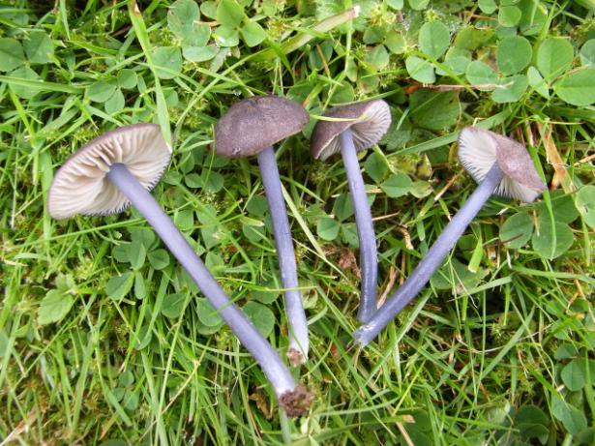
Entoloma atrocoeruleum. Not uncommon in HW grasslands

Visits were made to these hotspot sites (referred to as sub sites in this report) on October 2nd and 4th 2013, with the assistance of Shaun Hackett and Andy Mclay. Survey took the form of informal ground walking, using surveyor experience to target suitable micro sites within the grasslands. The dry conditions during the summer and autumn of 2013 meant that north facing slopes were in general more productive than south facing and some previously visited south facing sites were not visited in 2013 for this reason. Collections that could not be identified in the field were taken back and checked using keys and a microscope. Any collections of particular interest were dried and will be forwarded to the Royal Botanic Gardens, Kew for confirmation and storage in the fungarium.

Table 1: Full list of site locations from Mclay 2012. Highlighted sites were also visited in 2013
Site | Grid ref
West of Steel Rigg carpark | NY749676
Walltown Crags | NY679666
Caw Gap | NY727677
South of Highshields Crags | NY767677
Aesica Roman Fort | NY703667
Limestone Corner | NY875716
Above Hexagon Plantation | NY732672
West of Housesteads | NY781683
Sewingshields Crags | NY799697
Housesteads | NY794691
West of Allolee | NY684665
Hotbank Farm | NY771679
Peel Crags | NY757676
Winshields Crags | NY748675
East of Sewing Shields | NY820705
Vallum: East of Carrawbrough Farm | NY868713
West of Carraw | NY847710
Carvoran | NY667660
Cawfield Crags | NY716667
Using criteria for assessment of the value of waxcap grasslands: The species thresholds for conservation interest proposed by Rald (1985) and adapted by Vesterholt et al (1999) were based on Continental Northern European waxcap sites findings. These have been updated (Genney et al 2009) to present thresholds that are of particular relevance to UK grasslands, based on further survey of UK grasslands post 1999 (McHugh et al 2001; Newton et al 2003; Evans 2003; Griffith et al 2006).

The Rald / Vesterholt thresholds also referred only to the Hygrocybe 'waxcap' species. Some sites may not meet the suggested thresholds for this group but still be exceptional for other fungi known to have the same habitat requirements (the Clavariaceae, Entoloma, Geoglossaceae and Dermoloma). Favouring Hygrocybe in these systems occurred for pragmatic reasons - they are easy to see and relatively easy to identify to species level, in some instances without the need for microscopic examination. By offering thresholds to each of the CHEGD groups, the authors of the JNCC document have gone some way to addressing this problem although specialist identification skills are necessary to take full advantage of this.

The JNCC guidelines do not however, offer any threshold for sites of international importance so the Vesterholt proposals (Table 2) remain the only work that has attempted to assess sites in an international context although it is still not clear how reliable they are and the suggested thresholds may be altered as our understanding of species definition and distribution improve.

Table 2: Rald's Scale (1985) as adapted by Vesterholt et al (1999)
Conservation value | waxcap species: single visit | Waxcap species: multiple visits
Of international importance | 15+ | 22+
Of national importance | 11-14 | 17-21
Of regional importance | 6-10 | 9-16
Of local importance | 3-5 | 4-8
Of no importance | 1-2 | 1-3

The JNCC document clearly states that its threshold values (Table 3) are for guidance only; they are an indication that a site should be considered for SSSI designation and thus be of national importance. In addition to these thresholds however, account may need to be taken of regional variation and the actual species recorded in relation to their known distribution both nationally and in the regional area of search. Expert judgement will thus still normally be required for site assessment.

It should be noted that molecular research into the taxonomy of Hygrocybe is currently being undertaken. It appears that there are a number of cryptic species and it is likely that some new species will need to be described, several of which could prove to be endemic to the UK (M. Ainsworth pers. comm.). The findings of this work when published, will eventually mean that further revision of thresholds will have to be undertaken.

Table 3: JNCC thresholds for CHEGD species
 | Clavariaceae (Corals and Fairy Clubs) | Hygrocybe (Waxcaps) | Entoloma (Pinkgills) | Geoglossaceae (Earthtongues) | Dermoloma (Crazed Caps)
Single visit |  | 12
Multiple visits | 5 | 18 | 12 | 3 | 2

Suggestions for Hygrocybe species that would indicate sites of high diversity and conservation importance and which are used in this report, would include 'A' species as given by McHugh et al. (2001): Hygrocybe ingrata, H.lacmus (Grey Waxcap), H.nitrata (Nitrous Waxcap), H. ovina (Blushing Waxcap), H. punicea (Crimson Waxcap), H. splendidissima (Splendid Waxcap). Other 'A' non-Hygrocybe species from this source are Clavaria zollingeri (Violet Coral), Entoloma bloxamii (Big Blue Pinkgill), E. incanum (Mousepee Pinkgill), Microglossum olivaceum (Olive Earthtongue), Porpoloma metapodium (Mealy Meadowcap) and Trichoglossum walteri.

From the 'B' species list, the following species would be of conservation interest in the context of the current project: Hygrocybe aurantiosplendens (Orange Waxcap), H. calciphila (Limestone Waxcap), H.calyptriformis (Pink Waxcap), H. citrinovirens (Citrine Waxcap), H. colemanniana (Toasted Waxcap), H. flavipes (Yellow Foot Waxcap), H. intermedia (Fibrous Waxcap). A full list of all McHugh species is given in Appendix 1.

In a Scottish context, which ecologically might be expected to have some affinity with the far north of England, Newton et al. (2003) list H. aurantiosplendens (Orange Waxcap), H. chlorophana var. aurantiacum, H. ingrata, H. ovina (Blushing Waxcap), and H. spadicea (Date Waxcap) as suggesting a site of high conservation importance. In a recent revision of his monograph, Boertmann (2010) suggests that H. punicea (Crimson Waxcap) is likely to be found in grasslands that have a very long continuity of management.

The use of scoring systems i.e. 'weighted' species that might indicate a site of conservation interest, has been suggested (McHugh et al 2001) and was used by Mclay (2012). Data analysis undertaken by Newton (2003) however, suggests that there is still much work to be done before such systems are reliable. Expert opinion remains the most useful tool to give a meaningful interpretation to the interest of species and species assemblages recorded.

Other tools for the assessment of the conservation interest of grassland sites would be the UK Biodiversity Action Plan (UKBAP) (Anon. 2008) grassland fungi species Entoloma bloxamii (Big Blue Pinkgill), Geoglossum atropurpureum, Hygrocybe spadicea (Date Waxcap) and Microglossum olivaceum (Olive Earthtonge) and any additional grassland species listed in the preliminary assessment fungal red list (Evans 2007).

Basidiomycete nomenclature is taken from the ‘Checklist of the British and Irish Basidiomycota’ (Legon & Henrici 2005) and its subsequent updates (2006, 2007, 2008, 2009, 2011 found at http://www.basidiochecklist.info/LatestUpdates.asp ).

All the records will be forwarded to the Fungal Records Database of Britain and Ireland managed by the British Mycological Society (FRDBI), which in turn feeds into the National Biodiversity Network Gateway. English names are taken from an ongoing project with names listed on the BMS website http://www.britmycolsoc.org.uk/library/ .

Results
UK Biodiversity Action Plan (UKBAP) species, Preliminary Assessment Red List species and other species of conservation interest:
- Entoloma bloxamii (Big Blue Pinkgill) is known from Limestone Corner (S. Hackett). UKBAP species.
- Microglossum olivaceum (Olive Earthtongue) was recorded in 2012 at three sub sites (Steel Rigg car park: west of, Hotbank and Sewing Shields: east of ) but not found in 2013. Known also from Limestone Corner in 2011 (Mclay 2012). UKBAP species.
- Hygrocybe spadicea (Date Waxcap) recorded for the first time in 2013 at Highshields Crags (NY7635667815). The single location of the four fruiting bodies of this fungus were on a south facing slope below a basalt outcrop - exactly the habitat that Boertmann (2010) describes in his monograph. This is a distinctive species that is unlikely to be overlooked and is thus almost certainly genuinely rare. It is of considerable conservation interest, a UKBAP species and on the preliminary assessment red list as 'near threatened'.
- Clavaria straminea (Straw Club) was recorded in 2013 at Steel Rigg car park: west of and Hexagon Plantation: above. Listed as 'near threatened' on the preliminary assessment red list, this is a small and easily overlooked club fungus.

A number of other species of conservation interest were recorded in 2013.
- Entoloma ianthinum. Collection to be sent to Kew. If confirmed this species will be new to the UK. Recorded in 2013 from one site - Limestone Corner
- Hygrocybe aurantiosplendens (Orange Waxcap) recorded at one new sub site in 2013 - Highshields Crag
- H. citrinovirens (Citrine Waxcap) - listed as 'occasional' in its English distribution by Legon & Henrici (2005) this species was recorded at one new sub site in 2013 - Steel Rigg car park: west of
- H. intermedia (Fibrous Waxcap) - listed as 'occasional' in its English distribution by Legon & Henrici (2005) this species was recorded at one new sub site in 2013 - Walltown Crags: south
- H. nitrata (Nitrous Waxcap) recorded at one new sub site in 2013 - Highshields Crag
- H. punicea (Crimson Waxcap) recorded at five of the eight sub sites visited in 2013
- H. splendidissima (Splendid Waxcap) recorded at one new site in 2013 - Steel Rigg car park: west of

Interpreting the data:
Using the survey data from both 2012 and 2013, plus additional collections from S. Hackett (pers. comm), HW has a CHEGD score of 10:31:22:2:1 giving a total of 66 CHEGD species. Placing this into a table of top UK sites from Griffith et al (2013), HW is ranked third in the UK for the number of Hygrocybe species recorded in a site (Table 4) but first in England, making it of national importance.

Given the paucity of waxcap grasslands in other countries (see Discussion, below) this would suggest that HW is of international importance with the number of Hygrocybe well in excess of the threshold recommended by Rald and Vesterholt i.e. 22+ (Table 2).

The CHEGD totals also exceed the thresholds given by JNCC (Table 3) for each of the groups apart from Geoglossaceae and Dermoloma where it is below the threshold for interest.

Given the number of species that are of conservation interest spread throughout the sub sites, there is no doubt that this is an exceptional site worthy of consideration for designation as an SSSI for its waxcap interest.

Table 4: Top 10 sites for Hygrocybe species and total CHEGD taxa in the British Isles (based on a table in Griffith et al 2013)
Rank | Site name | Country | Site area (ha) | No visits | No Hygrocybe spp | CHEGD  totals
1 | Trawscoed | Wales | 418 | >20 | 34 | 73  (15:34:21:3:0)
2 | Mynydd Epynt | Wales | 14568 | >20 | 33 | 62  (10:33:12:7:0)
3 | Hadrian's Wall | England | 250 | >20 | 31 | 66  (10:31:22:2:1)
4= | Longshaw Estate | England | 280 | >20 | 30 | 74  (11:30:26:7:0)
4= | Alport | England | nk | >20 | 30 | 66  (10:30:20:6:0)
4= | Glan Ddyrys | Wales | 5.4 | >20 | 30 | 57  (10:30:9:6:2)
7 | Moel Tryfan | Wales | 15 | c. 10 | 29 | 56  (11:29:11:5:0)
8 | Llanishen | Wales | 43.7 | >20 | 28 | 43  (7:28:6:1:1)
9= | St Kilda | Scotland | c. 1500 | <10 | 27 | 70  (7:27:32:3:1)
9= | Goodmans | England | 250 | >20 | 27 | 60  (0:27:28:0:5)
9= | Moel y Ci | Wales | 142 | >20 | 27 | 56  (10:27:15:4:0)
9= | Gilfach Farm | Wales | 84.7 | c. 10 | 27 | 52  (10:27:11:4:0)
9= | Hafod | Wales | 26.3 | >20 | 27 | 45  (6:27:10:1:1)
9= | Hopetoun House | Scotland | 2 | 15 | 27 | 42  (9:27:5:1:0)

Table 5 gives the CHEGD scores for each of the sites visited in 2013 (i.e. single visit) and Table 6 gives the 2013 CHEGD scores with the addition of species recorded in 2012 (i.e. multiple visits).

'Steel Rigg car park: west of' is of exceptional interest, coming top in both single and multiple visit analyses. This sub site is worthy of consideration for SSSI designation in its own right.

The next 4 sub sites remain in the top 5 but with altered positions. A significant decrease in Hygrocybe species in 2013 at Highshields Crags is almost certainly attributable to the south facing slope and a dry fruiting season. The south facing slopes at Walltown were similarly poor with most species coming from the north side of HW. The bottom 3 sites remain consistently so. Highshields Crags sub site is worthy of special mention as it has been ranked fifth and third in Tables 5 and 6 respectively but is currently the only site for UKBAP species Hygrocybe spadicea on HW. This sub site is thus of considerable conservation interest, something that might not be apparent just from the CHEGD totals.

The increase in Entoloma species is consistent with surveyor attention. It is a genus that is both large and difficult to work with. Entoloma species often appear earlier in the season than Hygrocybe but were present in reasonable numbers during the 'dry/late' 2013 autumn season. The 'Steel Rigg car park: west of' and Limestone Corner sites both supported good numbers of fruit bodies and diversity of species in Entoloma and could be of particular interest for this genus.

The Geoglossaceae were not fruiting in any number or diversity at the time of the 2013 visit.

Details of the fungi recorded at each HW sub site surveyed in 2013 are given in a separate Excel spreadsheet.

Table 5: 2013 sites ranked by CHEGD totals and genus scores (single visit). Figures in brackets refer to the totals from the 2012 visits NB all received more than one visit so not directly comparable and for general interest only.
 | C | H | E | G | D | Totals
Steel Rigg car park: west of | 4 (5) | 16 (20) | 10 (1) | 1 (2) | 0 (1) | 31
Limestone Corner | 2 (3) | 10 (14) | 9 (0) | 0 (0) | 1 (0) | 22
Walltown Crags | 0 (2) | 11 (19) | 6 (1) | 0 (1) | 1 (1) | 18
Hexagon Plantation: above | 3 (4) | 11 (12) | 2 (1) | 0 (1) | 0 (0) | 17
Highshields Crags: south of | 1 (1) | 8 (17) | 6 (1) | 0 (1) | 0 (0) | 15
Hotbank Farm | 0 (2) | 6 (10) | 2 (0) | 0 (1) | 1 (0) | 9
Carvoran | 1 (0) | 6 (7) | 0 (0) | 0 (0) | 0 (0) | 7
Peel Crags | 1 (2) | 4 (13) | 1 (0) | 0 (0) | 0 (0) | 6

Table 6: 2012 and 2013 CHEGD totals and genus scores (multiple visits)
 | C | H | E | G | D | Totals
Steel Rigg car park: west of | 7 | 22 | 10 | 2 | 1 | 41
Walltown Crags | 2 | 22 | 6 | 1 | 1 | 32
Highshields Crags: south of | 3 | 21 | 7 | 1 | 0 | 32
Limestone Corner | 4 | 15 | 10 | 0 | 1 | 30
Hexagon Plantation: above | 6 | 14 | 2 | 1 | 0 | 23
Hotbank Farm | 2 | 13 | 2 | 1 | 1 | 19
Peel Crags | 2 | 14 | 1 | 0 | 0 | 17
Carvoran | 1 | 10 | 0 | 0 | 0 | 11

Sub site reports
The fact that species recorded in 2012 were not present in 2013 and vice versa is entirely in accordance with recommendations that surveys take place over more than one visit and preferably in more than one year. Several sites (e.g. Walltown Crags (the southern part), Highshields Crags and Limestone Corner) were less diverse in Hygrocybe species in 2013; almost certainly a reflection of the dry conditions during the early part of the fruiting season and not any changes in management. The only noticeable management change was a longer grass sward at Highshields Crags and may only be a short term phenomenon.

Full site details including sub site locations with maps are given in Mclay (2012).

Steel Rigg car park: west of: This sub site has come out top in all ranking systems applied to the surveyed sub sites. It comprises a cattle grazed field running along the crest of the hill and dropping away on the north side of HW to a steep north facing slope. At the top of the slope there is evidence of past disturbance in the form of Roman quarry workings (Mclay 2012). These old workings and the north facing slopes proved to be the most productive. 14 new CHEGD species including 9 Entoloma were recorded in 2013. This sub site could well be of particular interest for its Entoloma as well as Hygrocybe species.

Flatter areas at the top of the field used for feeding the cattle and at the bottom of the north facing slope which was very wet, did not support significant populations of CHEGD species.

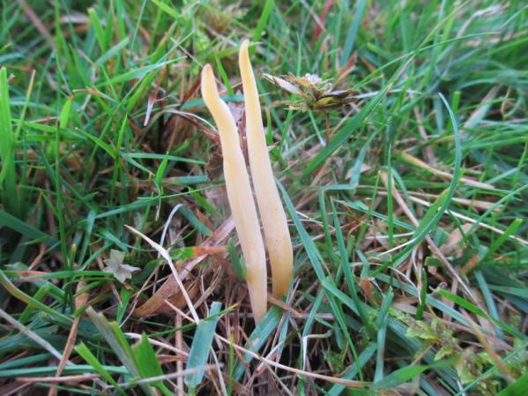
Clavaria straminea (Straw Club)

Species of conservation interest 2013: Clavaria straminea, Hygrocybe citrinovirens, H. nitrata, H. punicea, H. splendidissima. In addition, recorded during 2012, Hygrocybe aurantiosplendens, H. flavipes, H.ovina and Microglossum olivaceum

Walltown Crags: The south facing slopes that had been so productive in 2012 were poorly populated with CHEGD fruiting bodies. Hygrocybe intermedia was present for the first time however and these slopes provide excellent potential habitat for H. spadicea.

The north side of the crags were much more productive in 2013. Previously disturbed ground comprising old quarry workings (A. Mclay pers. comm) has grassed over and a short sward is maintained by grazing. This supports diverse populations of both Hygrocybe and Entoloma and when put together with the collections from the south facing slopes, gives the sub site an equal second place (Table 6) in a HW context. 8 new CHEGD species including 5 Entoloma were recorded in 2013.

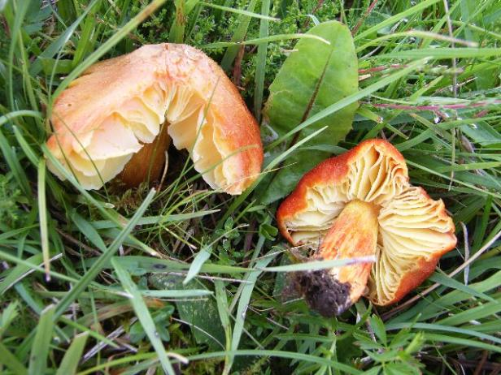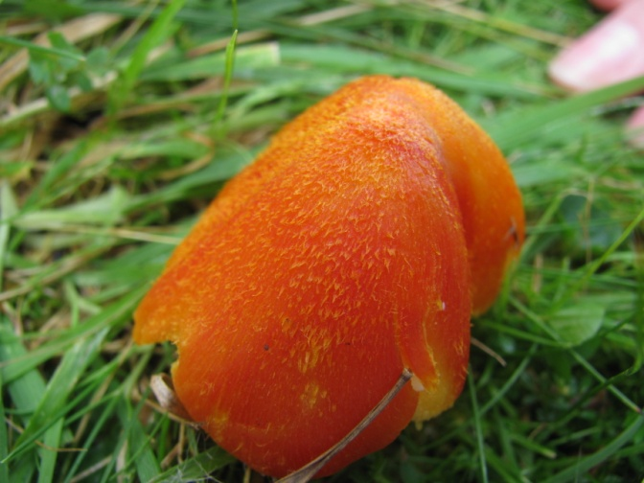
Hygrocybe intermedia (Fibrous Waxcap) H. intermedia showing fibrous cap (S. Hackett)

Species of conservation interest 2013: Hygrocybe intermedia. In addition recorded during 2012, H. flavipes, H. ovina, H. punicea and H. splendidissima.

Highshields Crags: south of: The sward of this sub site was noticeably longer than during the 2012 visits (A. Mclay pers. comm). At this stage in its development, the sward height it is less likely to have impacted on target species numbers than the fact that the ground is south facing and droughted in the dry 2013 season. Although the overall diversity was lower in 2013, 11 new CHEGD species were recorded including 6 Entoloma and the UKBAP and red listed species Hygrocybe spadicea.

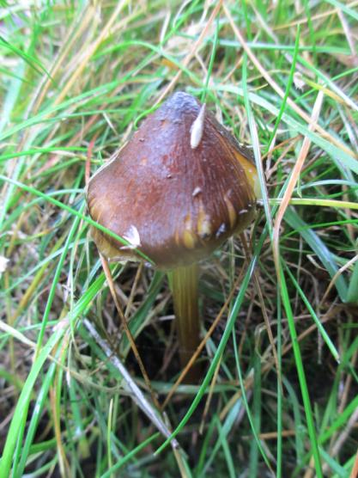
Hygrocybe spadicea (Date Waxcap)

Species of conservation interest 2013: Hygrocybe aurantiosplendens, H. nitrata and H. spadicea. In addition recorded during 2012, H. punicea.

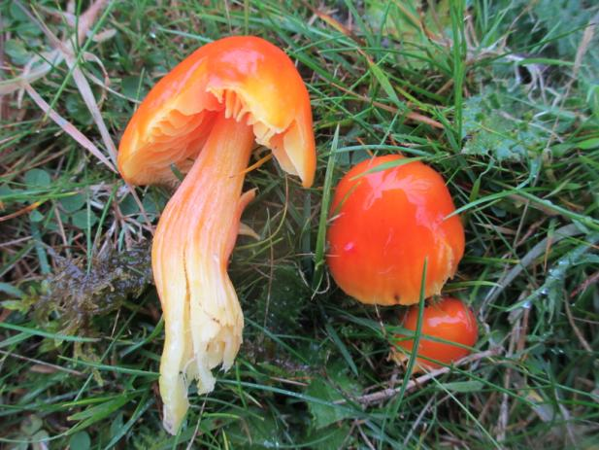
Hygrocybe aurantiosplendens (Orange Waxcap)

Limestone Corner: This sub site exhibits evidence of past quarrying activity that has now grown over and is grazed by cattle and sheep. 11 new CHEGD species were recorded including 9 Entoloma species. This site could be of particular interest for Entoloma as well as Hygrocybe.

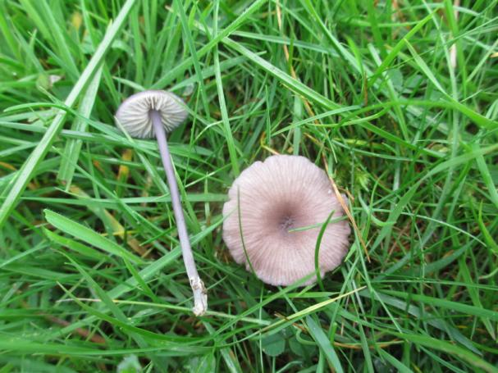
Entoloma ianthinum (identification to be confirmed)

Species of conservation interest 2013: Hygrocybe punicea. Entoloma ianthinum, if confirmed, would be new to the UK and thus of considerable interest. In addition recorded during 2012 and earlier, H. calyptriformis and UKBAP species Entoloma bloxamii and Microglossum olivaceum (S. Hackett pers comm).

Hexagon Plantation: above:
A north facing slope currently grazed by horses continued to support a limited number of species of conservation interest. The area of most interest was a large, north facing bank running the length of the field. Six new CHEGD species were recorded in 2013. Species of conservation interest 2013: Clavaria straminea, Hygrocybe citrinovirens, H. punicea.

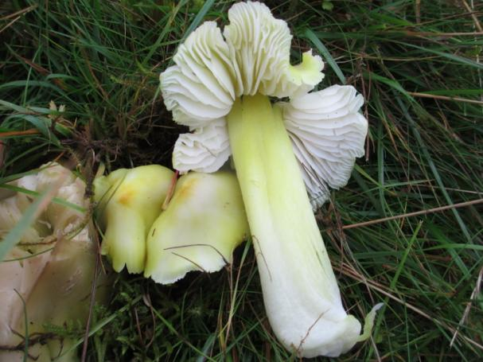
Hygrocybe citrinovirens (Citrine Waxcap)

Hotbank Farm:
A small and for the most part south facing site. Six new CHEGD species were recorded in 2013. There were no species of particular conservation interest apart from the rarely recorded Entoloma queletii. Assessments regarding the conservation interest of Entoloma species have been limited to the most distinctive species only so the importance of this species is not known. In 2012 Hygrocybe colemanniana, H. punicea and UKBAP species Microglossum olivaceum were recorded.

Peel Crags:
A small area of largely south facing ground, this site produced Hygrocybe punicea of conservation interest in 2013. Only 1 CHEGD species was added during 2013. The 2012 visit produced a good range of Hygrocybe but nothing outstanding apart from H. punicea.

Carvoran:
Six new CHEGD species were recorded n 2013 including species of interest Hygrocybe punicea. Other species of interest recorded in 2012: Hygrocybe flavipes, H. intermedia.

The full list of CHEGD for HW is given in Appendix 2.

The presence of Helianthemum nummularium (rockrose) was noted at several of the sites visited (e.g. Peel Crags, Walltown Crags) and although not the target of this survey, several fungal associates were noted. Rockrose is an ectomycorrhizal plant i.e. in a beneficial symbiotic relationship with what appears to be a variety of fungi more often associated with birch, oak, hazel or occasionally creeping willow, beech or conifer. This relationship of fungi and rockrose is not widely known about and has received very little survey attention. It certainly gives an additional dimension to the interest value of sites with rockrose. According to Henrici (2010) there is nothing in the distribution of rockrose to suggest that the fungi are relicts of lost woodland, forced to seek refuge on a new host. There could be some implications for waxcap fungal diversity in that it is thought that woodland ectomycorrhizal fungi may generally outcompete waxcap fungi. The presence of rockrose may therefore not be beneficial for waxcaps (Griffith et al 2013). The small populations that were noted, are unlikely to cause problems on a site of this scale and will just add to the overall fungal diversity.

Discussion
The cultural significance of waxcap grasslands should not be overlooked. The necessary low input management regime (nutrient input and physical disturbance will disturb the soil profiles to the detriment of many soil organisms) has given rise to the fungal equivalent of the highly valued hay meadow habitat. The seasonal appearance of brightly coloured fruiting structures reliant on traditional, low input farming practices is common to both. Given the cultural importance of the Hadrian's Wall monument, this aspect of waxcap grassland has a particular resonance.

Whilst CHEGD species have a worldwide distribution, occurring in boreal and tropical systems (Halbwachs et al 2013), waxcap grasslands are currently virtually unknown outside northern Europe. Griffith et al (2013) attribute this to a combination of factors including recent glaciation, high rainfall levels and distinctive patterns of distribution of large mammalian herbivores, in turn linked to high human population densities. Given that there are relatively few habitats in the UK whose conservation value is significant in an international context, mainly because of human activities over recent centuries, waxcap grassland is outstanding in this respect. Low imput management has maintained these diverse soil profiles and their importance at both national and international levels has only recently been recognised so that much of the habitat has already been lost.

The international recognition of the conservation importance of waxcap grassland (Senn-Irlett et al 2007) will contribute to their protection through agri-environment schemes and other legislative means. The designation of the HW grasslands as an SSSI notified for its waxcap grassland interest would present an opportunity, through management agreements and awareness raising, to both maintain existing and promote the development of new waxcap grasslands. Future use of agri-environment schemes should be considered to compensate the land users for any loss of income due to management restrictions e.g. reduction in fertiliser application, on a site where physical characters and constraints already imposed to conserve the archaeology, make farming difficult in the current economic situation.

Management recommendations
- Designation of the site for its international and national importance for waxcap fungi would raise the profile of this group of organisms and their needs. This in turn should prevent the loss of existing hotspots through inappropriate management and enable the development of other sites along HW.
- Fertilisation of the grazing sward should be avoided. The application of large amounts of farm yard manure or NPK fertilisers to 'improve' the grazing would not interfere with the archaeology and is thus potentially the most likely cause of waxcap grassland habitat loss on this site.
- Maintaining a short vegetation sward to comply with the need to maintain the historic monument, is most easily achieved by grazing. This is entirely compatible with the needs of waxcap fungi as long as disturbance of the soil profiles or intensive fertilisation do not take place.
- Give consideration as to how agri-enviroment schemes may be used to assist farmers to maintain the low input management necessary for diverse populations of CHEGD species.
- The mowing of small units of heavily visited ground is also compatible with the needs of waxcap fungi. In this instance reseeding or the application of fertilisers should not take place. The removal of grass clippings is desirable to prevent the accumulation of nitrogen in the soil.
- Monitoring of hotspots should be established to ensure continuity of low input management e.g. Highshields Crags where sward height had increased in 2013.
- Further CHEGD species will certainly be recorded and further survey effort is recommended. The Geoglossaceae are undoubtedly under recorded and Clavariacea, Hygrocybe and Entoloma will produce further records particularly if specialist texts and a microscope are used in the identification. Further sites for H. spadicea are very likely to be found given the basalt outcrops and south facing slopes present.
- Should any designation for the waxcaps along HW be considered, further survey of the grasslands along HW but out with NNP is recommended to assist with delimiting designation boundaries. Currently only the areas within the NNP have been surveyed because of funding restrictions.

References
Anon. (2008). UK List of Priority Species UK Biodiversity Action Plan Website www.ukbap.org.uk/PrioritySpecies.aspx?group=3

Arnolds, E. (1982). Ecology and coenology of macrofungi in grassland in Drenthe, the Netherlands. Autecology and Taxonomy, Vol. 2. Parts 2 & 3. Ganter Verlag K.G., Vaduz, Germany

Arnolds, E. (1988). The changing macromycete flora in the Netherlands. Transactions of the British Mycological Society 90(3), 391-406

Arnolds, E. & de Vries, B. (1989). Oecologische statistiek van de Nederlandse macrofungi. Coolia 32, 72-86

Bardgett, R.D. & McAlister, E. (1999). The measurement of soil fungi: bacterial biomass ratios as an indicator of ecosystem self-regulation in temperate meadow grasslands. Biology and Fertility of Soil 29(3) 282-290

Boertmann, D. (2010). The genus Hygrocybe: 2nd revised edition. Fungi of Northern Europe Vol. 1 Narayana Press, Denmark
Evans, S. (2003). Waxcap grasslands - an assessment of English sites. English Nature Research Report 555. English Nature, Peterborough

Evans, S.E. (2007). Preliminary assessment: the red data list of threatened British fungi British Mycological Society website - www.britmycolsoc.org.uk
Genney, D.R., Hale, A.D., Woods, R.G. & Wright, M. (2009). Grassland Fungi. JNCC Detailed guidelines for habitats and species groups. Chapter 18. http://jncc.defra.gov.uk/pdf/SSSIs_Chapter18.pdf
Griffith, G.W., Holden, L., Mitchel, D., Evans, D.E., Aron, C., Evans, S.
& Graham, A. (2006). Mycological survey of selected semi-natural grasslands in
Wales. Countryside Council for Wales Science Report 743

Griffith, G.W., Gamarra, J.G.P., Holden, E.M., Mitchel, D., Graham, A., Evans, D.A., Evans, S.E., Aron, C., Noordeloos, M.E., Kirk, P.M., Smith, S.L.N., Woods, R.G., Hale, A.D., Easton, G.L., Ratkowsky, D.A., Stevens, D.A. & Halbwachs, H. (2013). The international conservation importance of Welsh 'waxcap' grasslands. Mycosphere 4(5): 969-984. Mycosphere online edition www.mycosphere.org

Halbwachs, H., Karasch, P. & Griffith, G.W. (2013). The diverse habitats of Hygrocybe - peeking into an enigmatic life style. Mycosphere 4(4), 773-792. Mycosphere online edition www.mycosphere.org

Henrici, A. (2010).Notes & Records: Helianthemum associates. Field Mycology Vol.11(4) 141-143

Hewins, E.J., Pinches, C., Arnold, J., Lush, M., Robertson, H. & Escott, S. (2005). The condition of lowland BAP priority grasslands: results from a sample survey of non-statutory stands in England. English Nature Research Report 636. English Nature.

Holden, E. (2010). Waxcap fungi in Badenoch and Strathspey: A preliminary comparison of botanical and fungal (Waxcap) interest on farmland. Unpublished report to Cairngorms Campaign and Badenoch and Strathspey Conservation Group.

Legon, N. & Henrici, A. 2005. Checklist of the British and Irish Basidiomycota. Royal Botanic Gardens: Kew

McHugh, R, Mitchel, D, Wright, M &Anderson, R. 2001. The Fungi of Irish Grasslands
and their value for nature conservation. Proceedings of the Royal Irish Academy, 101B

Mclay, A. (2012). A waxcap grassland survey of Hadrian’s Wall, Northumberland. Unpublished report for Northumberland National Park

Newton, A.C., Davy, L.M., Holden, E., Silverside, A., Watling, R. & Ward, S.D. (2003).
Status, distribution and definition of mycologically important grasslands .in Scotland
Biological Conservation 111:11-23

Öster, M. (2008). Low congruence between the diversity of waxcaps (Hygrocybe spp) fungi and vascular plants in semi-natural grasslands. Basic and Applied Ecology 9, 514-522

Rald, E. 1985. Vokshatte som indikatorarter for mykologisk verifulde overdrevslokaliteter. Svampe 11:57-65

Senn-Irlet, B., Heilmann-Claussen, J., Genney, D. & Dahlberg, A. (2007). Guidance for the conservation of macrofungi in Europe. Document prepared for the Directorate of Culture and Natural Heritage Council of Europe, Strasberg

Vesterholt, J., Boertmann, D. & Tranberg, H. (1999). 1998 - et usaedvanlig godt ar for overdrevssvampe. Svampe, 40. 36-44

Appendix 1: Waxcap grassland quality scoring system McHugh et al 2001
Clavaria zollingeri A 4
Entoloma bloxamii A 4
Entoloma incanum A 4
Hygrocybe ingrata A 4
Hygrocybe lacmus A 4
Hygrocybe nitrata A 4
Hygrocybe ovina A 4
Hygrocybe punicea A 4
Hygrocybe splendidissima A 4
Microglossum olivaceum A 4
Porpoloma metapodium A 4
Trichoglossum walteri A 4
All other earthtongue species B 2
Clavaria fumosa B 2
Clavulinopsis umbrinella B 2
Dermoloma cuneifolium B 2
Entoloma porphyrophaeum B 2
Entoloma pratulense B 2
Entoloma prunuloides B 2
Entoloma roseum B 2
Hygrocybe aurantiosplendens B 2
Hygrocybe berkeleyi B 2
Hygrocybe calciphila B 2
Hygrocybe calyptriformis B 2
Hygrocybe citrinopallida B 2
Hygrocybe citrinovirens B 2
Hygrocybe colemanniana B 2
Hygrocybe constrictospora B 2
Hygrocybe flavipes B 2
Hygrocybe fornicata B 2
Hygrocybe glutinipes B 2
Hygrocybe helobia B 2
Hygrocybe intermedia B 2
Hygrocybe irrigata B 2
Hygrocybe phaeococcinea B 2
Hygrocybe quieta B 2
Hygrocybe radiata B 2
Hygrocybe vitellina B 2
Hygrocybe xanthocroa B 2
Ramariopsis kunzei B 2
All other waxcap species C 1
Clavulinopsis fusiformis C 1

Appendix 2: Full list of CHEGD species from Hadrian's Wall
Clavariaceae | Hygrocybe | Entoloma | Geoglossaceae | Dermoloma
Clavaria acuta | Hygrocybe acutoconica | Entoloma asprellum | Geoglossum fallax | Dermoloma cuneifolium
Clavaria fragilis | Hygrocybe aurantiosplendens | Entoloma atrocoeruleum | Microglossum olivaceum
Clavaria fumosa | Hygrocybe calyptriformis | Entoloma bloxamii
Clavaria straminea | Hygrocybe cantharellus | Entoloma conferendum
Clavaria zollingeri | Hygrocybe ceracea | Entoloma exile
Clavulinopsis corniculata | Hygrocybe chlorophana | Entoloma formosum
Clavulinopsis fusiformis | Hygrocybe citrinovirens | Entoloma griseocyaneum
Clavulinopsis helvola | Hygrocybe coccinea | Entoloma cf ianthinum
Clavulinopsis laeticolor | Hygrocybe colemanniana | Entoloma infula
Clavulinopsis umbrinella | Hygrocybe conica | Entoloma jubatum
 | Hygrocybe flavipes | Entoloma longistriatum
 | Hygrocybe fornicata | Entoloma pratulense
 | Hygrocybe glutinipes | Entoloma prunuloides
 | Hygrocybe intermedia | Entoloma pseudocelestinum
 | Hygrocybe irrigata | Entoloma pseudoturci
 | Hygrocybe laeta | Entoloma queletii
 | Hygrocybe miniata | Entoloma sericeum
 | Hygrocybe mucronella | Entoloma serricellum
 | Hygrocybe nitrata | Entoloma serrulatum
 | Hygrocybe ovina | Entoloma sodale
 | Hygrocybe pratensis | Entoloma tenellum
 | Hygrocybe psittacina | Entoloma turbidum
 | Hygrocybe punicea
 | Hygrocybe quieta
 | Hygrocybe reidii
 | Hygrocybe russocoriacea
 | Hygrocybe spadicea
 | Hygrocybe splendidissima
 | Hygrocybe virginea
 | Hygrocybe vitellina
Total 10 | Total 31 | Total 22 | Total 2 | Total 1

